Source code for the entire simulation is given. For the first, you should have a new Ubuntu system to building the environment of this experiment. Then you are supposed to follow the steps:
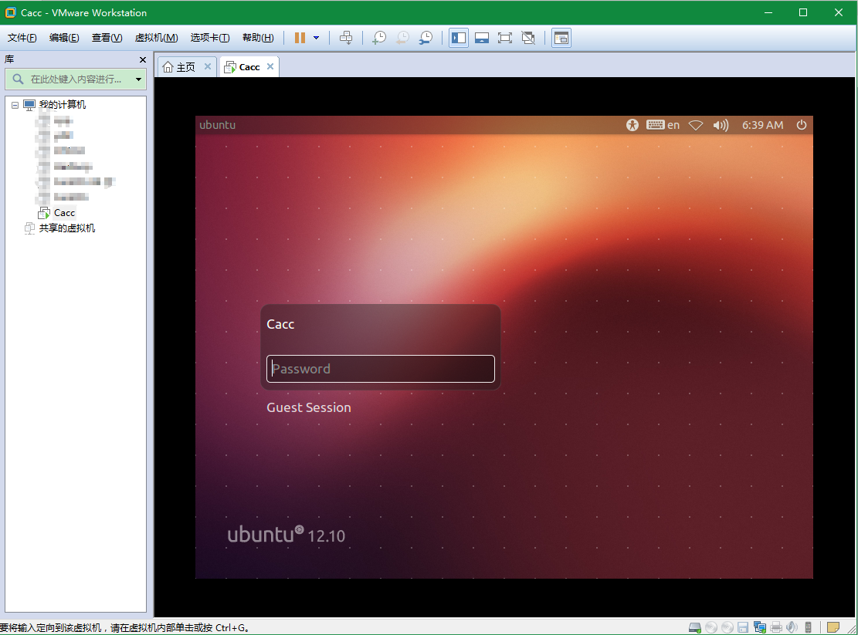

- Create a shared folder for Windows system and Ubuntu system, such as share_cacc, then put the compression package into share_cacc and decompress into share_cacc. The steps are as follows :
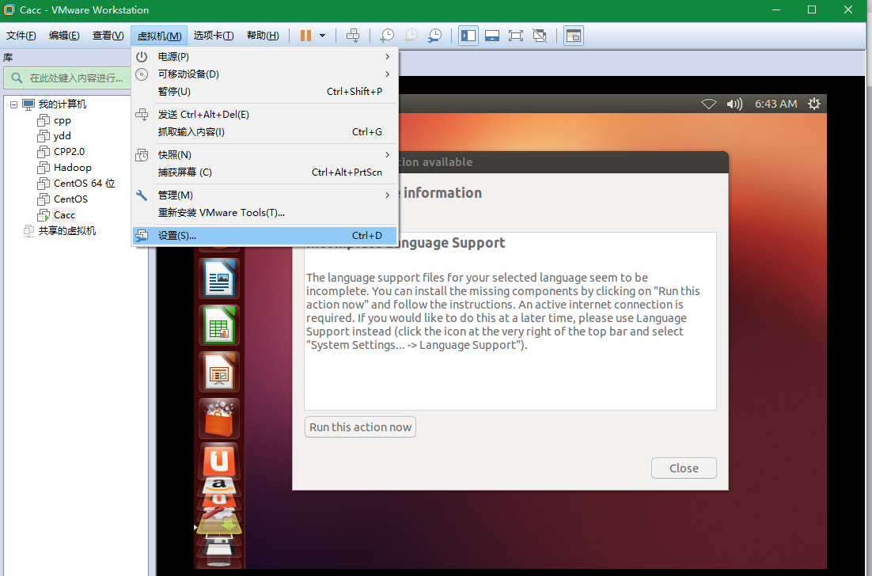

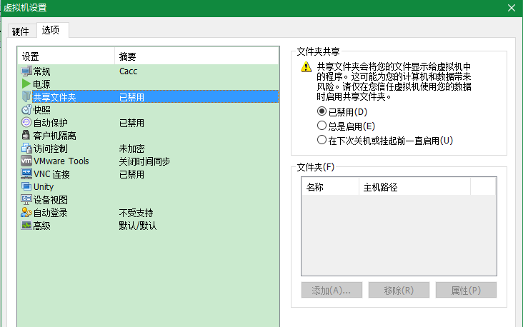
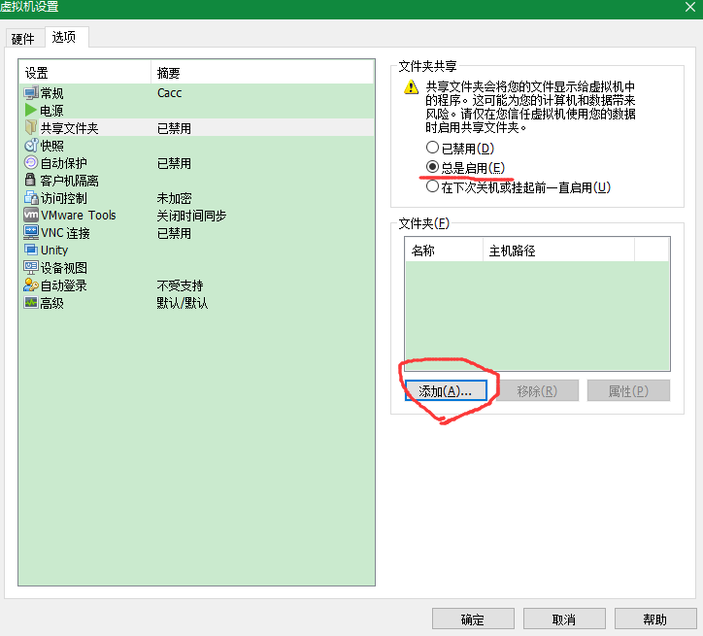

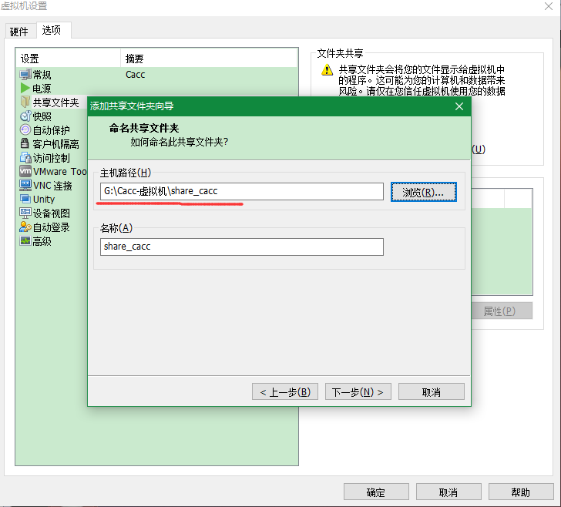
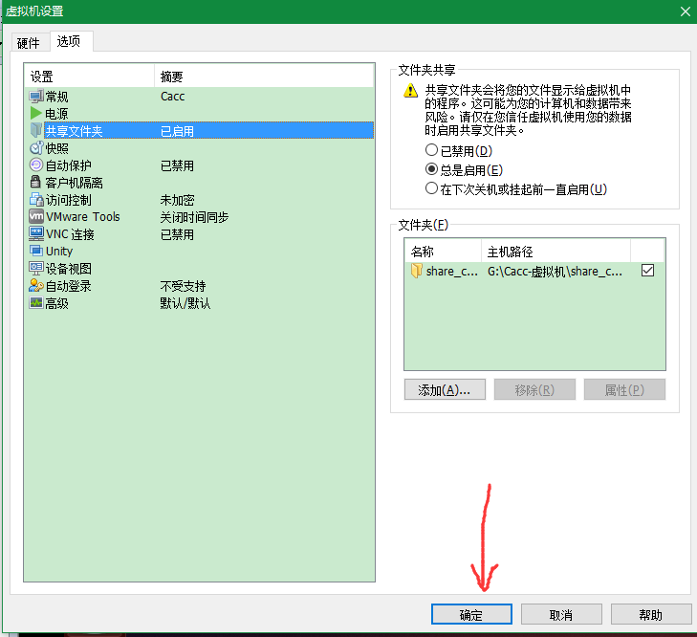

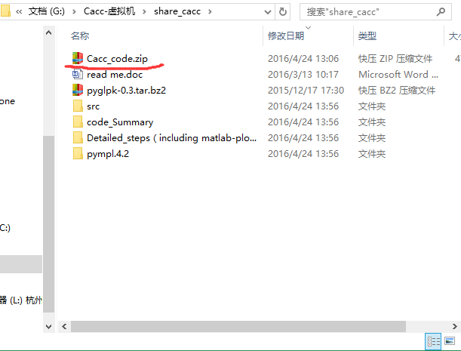

- Install pyglpk which is used to invoke tools of glpk.
2.1 Backup the old source——cp /etc/apt/sources.list /etc/apt/sources.list.old
2.2 Change the sources.list to netease source :
sudo gedit /etc/apt/sources.list
change the all old content to the following content:
deb http://mirrors.163.com/ubuntu/ precise main universe restricted multiverse
deb-src http://mirrors.163.com/ubuntu/ precise main universe restricted multiverse
deb http://mirrors.163.com/ubuntu/ precise-security universe main multiverse restricted
deb-src http://mirrors.163.com/ubuntu/ precise-security universe main multiverse restricted
deb http://mirrors.163.com/ubuntu/ precise-updates universe main multiverse restricted
deb http://mirrors.163.com/ubuntu/ precise-proposed universe main multiverse restricted
deb-src http://mirrors.163.com/ubuntu/ precise-proposed universe main multiverse restricted
deb http://mirrors.163.com/ubuntu/ precise-backports universe main multiverse restricted
deb-src http://mirrors.163.com/ubuntu/ precise-backports universe main multiverse restricted
deb-src http://mirrors.163.com/ubuntu/ precise-updates universe main multiverse restricted
2.3 Update the system——apt-get update
2.4 Install aptitude——apt-get install aptitude
Install python-dev——apt-get install python-dev
Install libgmp-dev——apt-get install libgmp-dev
Install glpk——apt-get install glpk
2.5 Import the installation package of “pyglpk-0.3.tar.bz2” into /usr:
cp -rf /mnt/hgfs/share_cacc/pyglpk-0.3.tar.bz2/ /usr
then decompress :
tar jxvf pyglpk-0.3.tar.bz2
2.6 Open the file of pyglpk-0.3 :
cd pyglpk-0.3
run respectively “make”,“make test”,“make install”:
make
make test
make install
and now, the pyglpk is installed.

- Install pymathProg which is used to invoke pyglpk.
3.1 Import “pympl.4.2” into /usr/cacc.
cp -rf /mnt/hgfs/share_cacc/pympl.4.2/ /usr
then open the file pymprog.py, delete lines 39 to 45 and save.
3.2 To write the path of pymprog.py into the new file a.pth :
vi a.pth
write the content and save：
/usr/pympl.4.2

- Install the networkx——aptitude install python-networkx
Attention: the first time asked whether to accept the solution, enter the N (that`s to say not installing the python-dev);
then it will provide a solution, enter the Y, and so it will solve it.

- For the second, to get the data of this experiment, you are supposed to follow the steps:
5.1 Create a new folder of cacc in /usr :
cd /usr
mkdir cacc
import the folder of “src” into /usr/cacc/:
cp -rf /mnt/hgfs/share_cacc/src/ /usr/cacc/
5.2 Build the environment of the program using:
cd /usr/cacc/src
/src/INSTALL.sh.
5.3 Import the generate_all.sh and all versions of the generate_xx.py of the folder “code_generate”into /user/cacc/src/.
For example: cp /mnt/hgfs/shar_cacc/code_generate/generate_all.sh /usr/cacc/src
5.4 Run the generate_all.sh :
./generate_all.sh
then you will get all data of the kinds of pictures in /usr/cacc/src/data_out/.
5.5 Export all data from /usr/cacc/src/data_out/ and respectively to plot them by corresponding Matlab programs.

Tips: The data of the distance matrix for each topology in /src/data_out/ comes from the real topology zoo.

